Shri Vile Parle Kelavani Mandal’s

**SHRI BHAGUBHAI MAFATLAL POLYTECHNIC**

Program: **Information Technology**

Course Name: **Programming In C++**

Course Code: **CPP198914**

Semester: II

Academic Term: **26th December2019 to 13th April 2020**

Mini Project Title: **Beauty products/Cosmetics**

**Student Name: Kresha Shah**

**Student Roll No: 1991050**

**Problem Statement & Features:**

**Description:** *This software is made in C++ language using Turbo C++ software .This software is easy to use and implement.*

Develop a C++ Mini Project for Beauty products/Cosmetics which offers the following features:

* Insertion of a new product in the product list
* Displaying all the products from the product list
* To find the valuation of each product
* To find the valuation(total investment) of all the products
* Search a particular product from the list
* To find the product having minimum price from the list.
* Products that are to be reordered.

**Modules to be implemented with timeline**

|  |  |  |  |
| --- | --- | --- | --- |
| **Sr.** | **Module Name** | **Description** | **Implementation Date** |
| 1 | insert_product() | Inserts a new product in the product list | 22nd March 2020 |
| 2 | display_product() | It shows all the products available | 22nd March 2020 |
| 3 | get_data() | Allows you to insert new product details | 25th March 2020 |
| 4 | put_data() | Shows the information of the inserted product | 25th March 2020 |
| 5 | valuation() | It calculates the valuation of Individual inserted product | 1st April 2020 |
| 6 | totalval() | It calculates the total valuation of all the inserted product | 5th April 2020 |
| 7 | minprod() | It will print the details of the product having minimum value | 13th April 2020 |
| 8 | search() | It will search the product with the help of code | 13th April 2020 |
| 9 | recordoflist() | It will display the record of products which are to be recorded soon | 13th April 2020 |

**Class Diagram**

Class product

**Mini Project Code**

**#include<iostream.h>**

**#include<conio.h>**

**#include<string.h>**

**class product**

**{**

**char name[30], brand[35],shade[15];**

**float price;**

**int quantity, code;**

**public:**

**static int total_product;**

**void insert_product();**

**void display_product();**

**void get_data();**

**void put_data();**

**float valuation();**

**void recordoflist();**

**static float totalval(product *p, int n);**

**static void search(product *p, int n);**

**static int minprod(product *p, int n);**

**};**

**int product::total_product;**

**void product::insert_product()**

**{**

**cout<<"To insert a new product following details are necessary"<<endl;**

**cout<<"Product Name=";**

**cin>>name;**

**cout<<"\nBrand=";**

**cin>>brand;**

**cout<<"\nShade=";**

**cin>>shade;**

**cout<<"\nCode=";**

**cin>>code;**

**cout<<"\nPrice=";**

**cin>>price;**

**cout<<"\nQuantity=";**

**cin>>quantity;**

**cout<<"Now your inserted cosmetic product is added to the final list"<<endl;**

**}**

**void product::display_product()**

**{**

**cout<<"List of all the cosmetic products available are:"<<endl;**

**cout<<"\nPrimer- which covers pores"<<endl;**

**cout<<"\nLip balm and Lipstick- lip balm makes your lips smoother and lipstick addes colour to your lips"<<endl;**

**cout<<"\nConcealer- cover up any marks on your skin"<<endl;**

**cout<<"\nFace Powder- used to prolong the effect of your makeup"<<endl;**

**cout<<"\nBlush- used to highlight the cheeks and make it prolong"<<endl;**

**cout<<"\nHighlighter- used to make all the sharp features of your face to stand out"<<endl;**

**cout<<"\nMascara and eyeshadow- Mascara is used for thickening the eyebrows and eyeshadow is used to highlight the eye and eyelids"<<endl;**

**cout<<"\nPerfume- it adds fragrance to your body"<<endl;**

**}**

**void product::get_data()**

**{**

**cout<<"Product Name=";**

**cin>>name;**

**cout<<"\nBrand=";**

**cin>>brand;**

**cout<<"\nShade=";**

**cin>>shade;**

**cout<<"\nCode=";**

**cin>>code;**

**cout<<"\nPrice=";**

**cin>>price;**

**cout<<"\nQuantity=";**

**cin>>quantity;**

**}**

**void product::put_data()**

**{**

**cout<<"Here are the details of your entered product"<<endl;**

**cout<<"Product name="<<name<<endl;**

**cout<<"Brand="<<brand<<endl;**

**cout<<"Shade="<<shade<<endl;**

**cout<<"Code="<<code<<endl;**

**cout<<"Price="<<price<<endl;**

**cout<<"Quantity="<<quantity<<endl;**

**}**

**float product::valuation()**

**{**

**return(price*quantity);**

**}**

**float product::totalval(product *p, int n)**

**{**

**int i;**

**float sum=0.0;**

**for(i=0;i<n;i++)**

**{**

**sum+=p[i].valuation();**

**}**

**return(sum);**

**}**

**int product::minprod(product *p, int n)**

**{**

**float minp=p[0].price;**

**int i ,id=0;**

**for(i=1;i<=n;i++)**

**{**

**if(p[i].price<minp)**

**{**

**minp=p[i].price;**

**id=i;**

**}**

**return(id);**

**}**

**}**

**void product::search(product *p, int n)**

**{**

**int scode,i,id=-1;**

**cout<<"Enter code to be searched"<<endl;**

**cin>>scode;**

**for(i=0;i<n;i++)**

**{**

**if(scode==p[i].code)**

**{**

**id=i;**

**break;**

**}**

**}**

**if(id==-1)**

**{**

**cout<<"Product not found"<<endl;**

**}**

**else**

**{**

**p[id].put_data();**

**}**

**}**

**void product::recordoflist()**

**{**

**product p[20];**

**cout<<"The following beauty products are to be recorded soon"<<endl;**

**for(int i=0;i<total_product;i++)**

**{**

**if(p[i].quantity<=10)**

**p[i].get_data();**

**}**

**}**

**void main()**

**{**

**int choice,n,i,true;**

**float val;**

**clrscr();**

**product p[100];**

**product p1;**

**cout<<"\t\t\tWELCOME TO BEAUTY PRODUCT SOFTWARE"<<endl;**

**while(true)**

**{**

**cout<<"\t\t\t\t***** MAIN MENU *****"<<endl;**

**cout<<"Follow the following instructions to use the software"<<endl;**

**cout<<"Press"<<endl;**

**cout<<" 1 -> For inserting new product details"<<endl;**

**cout<<" 2 -> To find the valuation of your inserted product "<<endl;**

**cout<<" 3 -> To display all he beauty products"<<endl;**

**cout<<" 4 -> Total investment you made while purchasing"<<endl;**

**cout<<" 5 -> To find the minimum price of your entered product"<<endl;**

**cout<<" 6 -> To search any product with the help of code"<<endl;**

**cout<<" 7 -> Some beauty products that are to be reorded"<<endl;**

**cout<<" ***PRESS ANY OTHER KEY TO ESCAPE***"<<endl;**

**cout<<"What do you want to know??"<<endl;**

**cin>>choice;**

**switch(choice)**

**{**

**case 1: clrscr();**

**cout<<"You can insert only 10 products"<<endl;**

**cout<<"How many products do you want to enter"<<endl;**

**cin>>n;**

**cout<<"Enter details for " << n << " products"<<endl;**

**for(i=0;i<n;i++)**

**{**

**p[i].insert_product();**

**}**

**cout<<"Product details are as below:"<<endl;**

**for(i=0;i<n;i++)**

**{**

**p[i].put_data();**

**}**

**p1.display_product();**

**break;**

**case 2:clrscr();**

**cout<<"You can insert only 10 products"<<endl;**

**cout<<"How many products do you want to enter"<<endl;**

**cin>>n;**

**cout<<"Enter details for " << n << " products"<<endl;**

**for(i=0;i<n;i++)**

**{**

**p[i].get_data();**

**}**

**cout<<"The valuation of entered product "<<endl;**

**for(i=0;i<n;i++)**

**{**

**val=p[i].valuation();**

**}**

**cout<<"Valuation of products"<<i+1<< " = " <<val<<endl;**

**break;**

**case 3: clrscr();**

**p1.display_product();**

**break;**

**case 4: clrscr();**

**cout<<"You can insert only 10 products"<<endl;**

**cout<<"How many products do you want to enter"<<endl;**

**cin>>n;**

**cout<<"Enter details for " << n << " products"<<endl;**

**for(i=0;i<n;i++)**

**{**

**p[i].get_data();**

**}**

**cout<<"The valuation of entered product="<<endl;**

**for(i=0;i<n;i++)**

**{**

**val=p[i].valuation();**

**cout<<"Valuation of entered product"<<i+1<< " = " <<val<<endl;**

**}**

**float totalval=product::totalval(p,n);**

**cout<<"Total valuation of your entered product is"<<totalval<<endl;**

**break;**

**case 5: clrscr();**

**cout<<"You can insert only 10 products"<<endl;**

**cout<<"How many products do you want to enter"<<endl;**

**cin>>n;**

**cout<<"Enter details for " << n << " products"<<endl;**

**for(i=0;i<n;i++)**

**{**

**p[i].get_data();**

**}**

**int id=product::minprod(p,n);**

**cout<<"product with minimum price:"<<endl;**

**p[id].put_data();**

**break;**

**case 6: clrscr();**

**cout<<"You can insert only 10 products"<<endl;**

**cout<<"How many products do you want to enter"<<endl;**

**cin>>n;**

**cout<<"Enter details for " << n << " products"<<endl;**

**for(i=0;i<n;i++)**

**{**

**p[i].get_data();**

**}**

**product::search(p,n);**

**break;**

**case 7: clrscr();**

**if(product::total_product>0)**

**{**

**p1.recordoflist();**

**}**

**else**

**{**

**cout<<"!!!WARNING!!!"<<endl;**

**cout<<"Please add some products at first"<<endl;**

**}**

**break;**

**default:cout<<"End of the program"<<endl;**

**true=0;**

**break;**

**}**

**}**

**getch();**

**}**

**Mini Project Result**

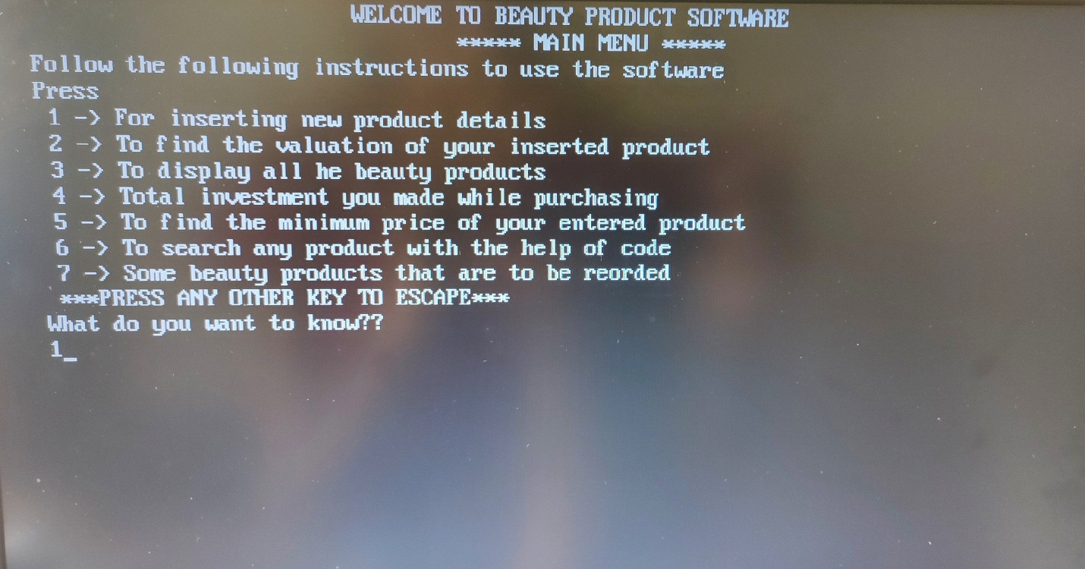

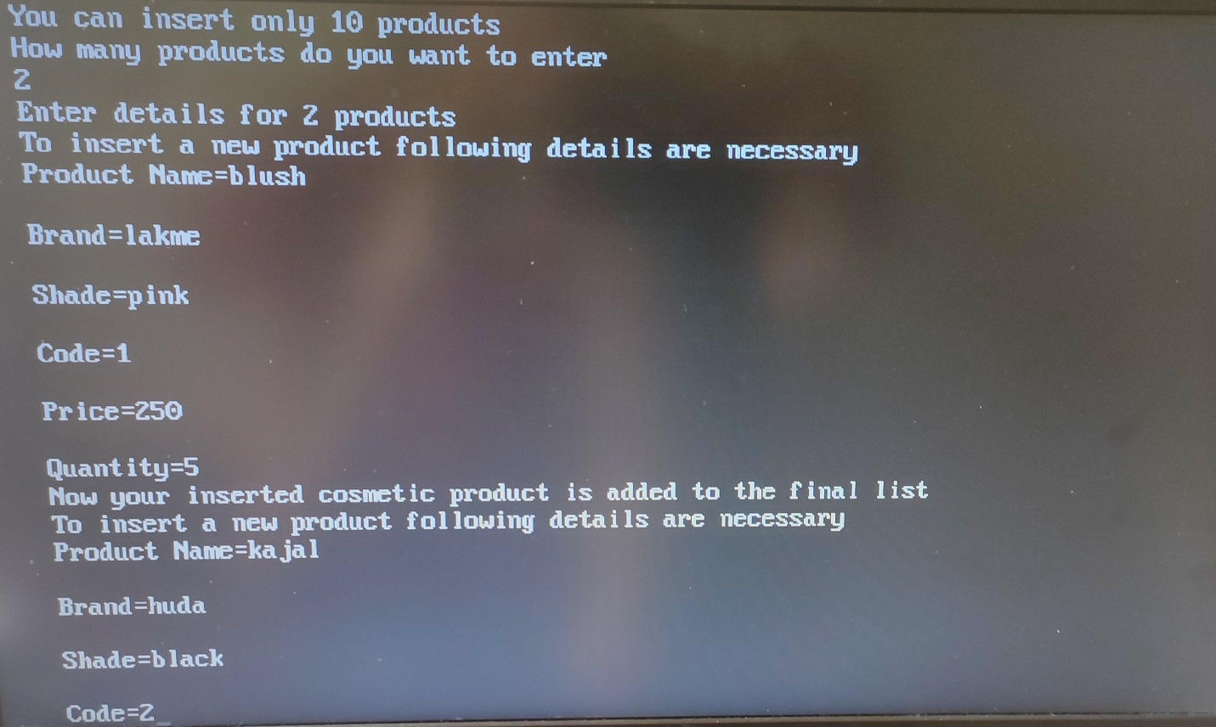

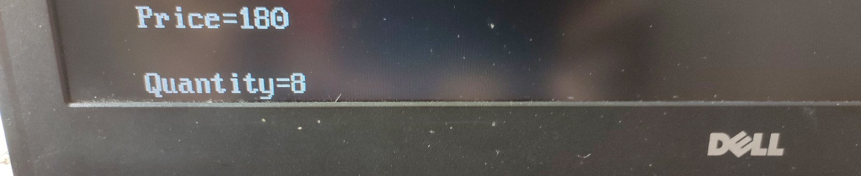

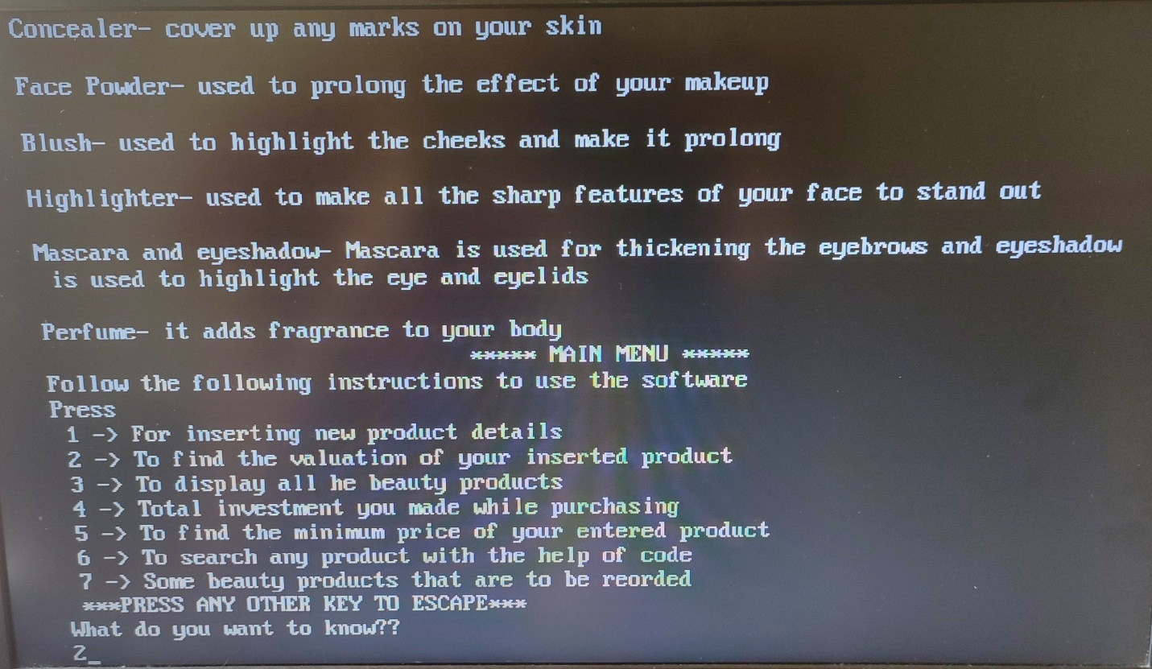

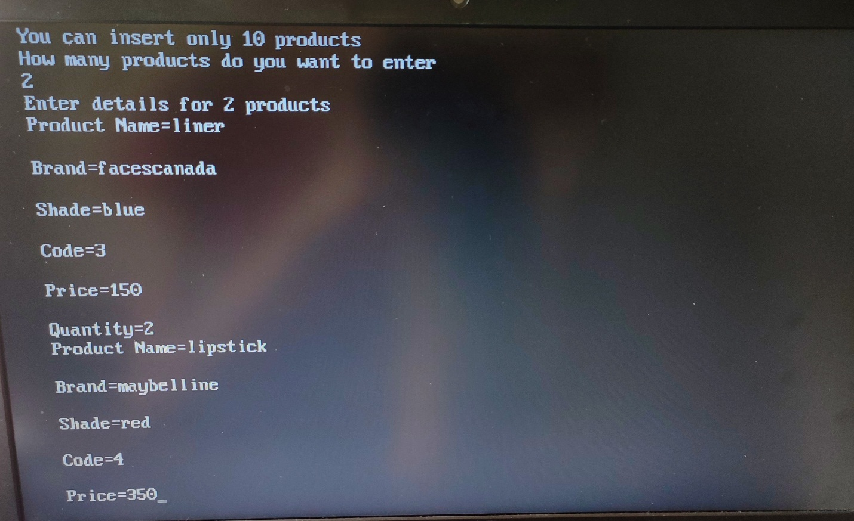

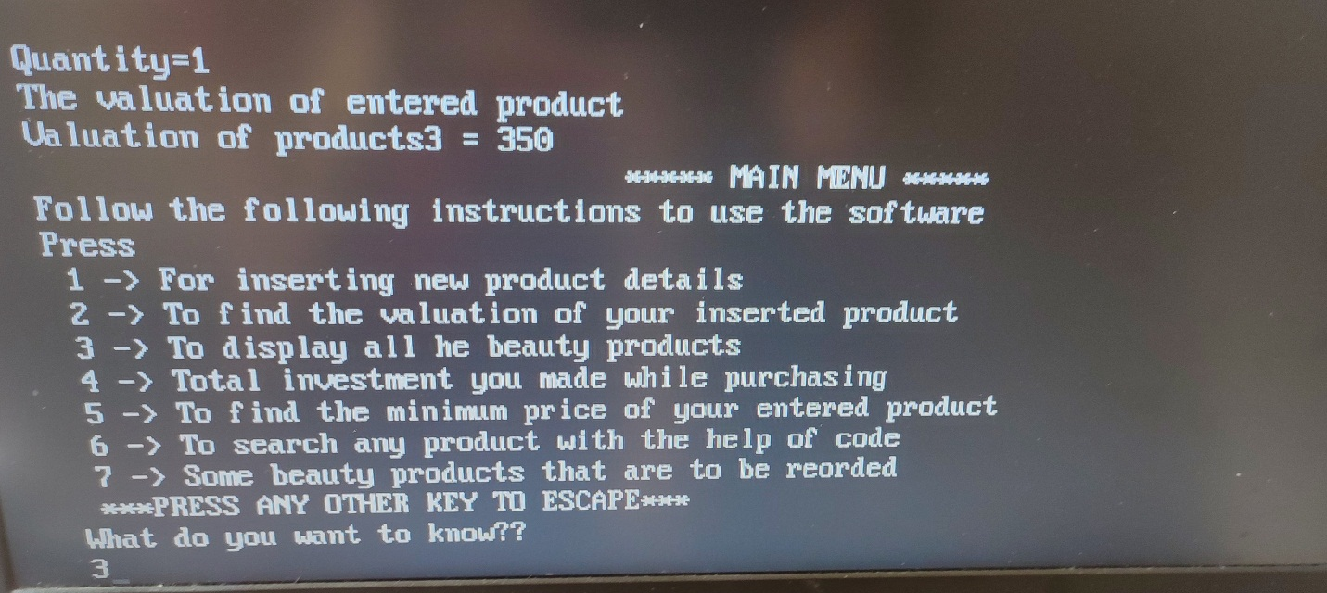

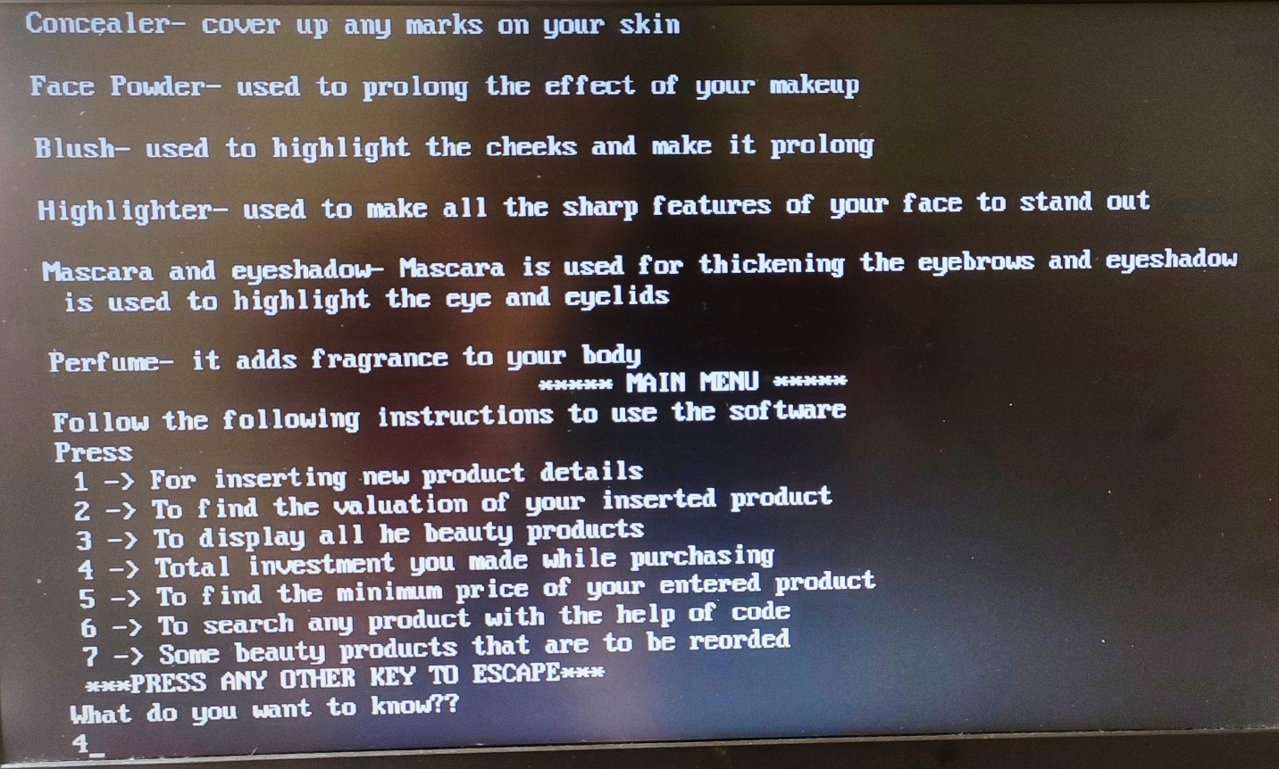

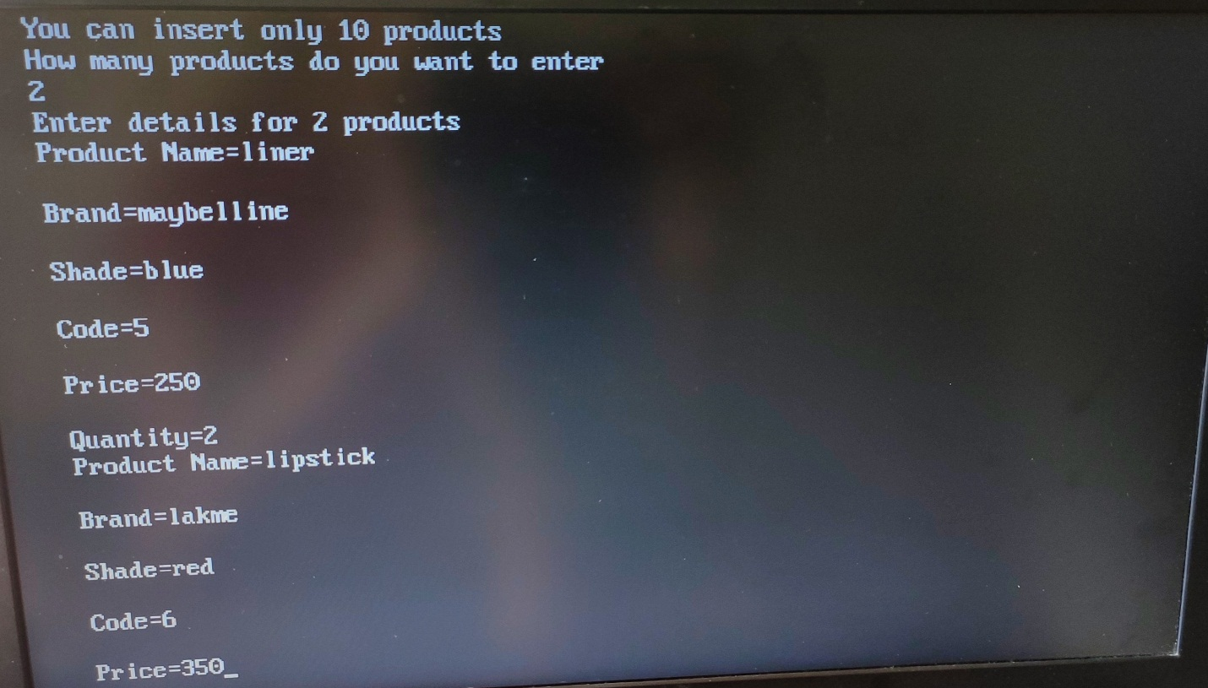

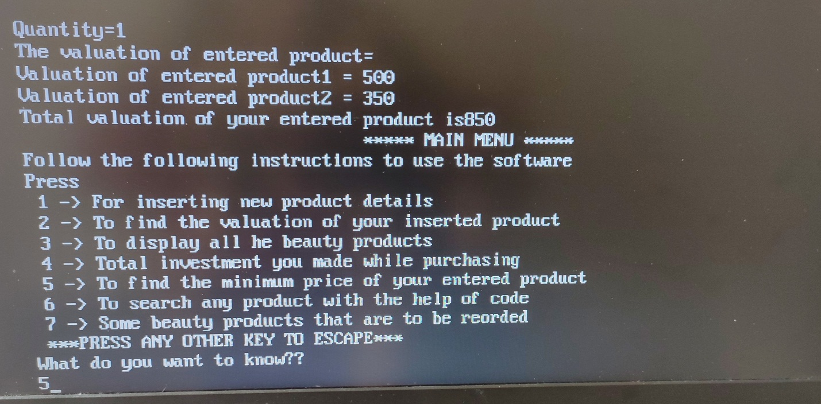

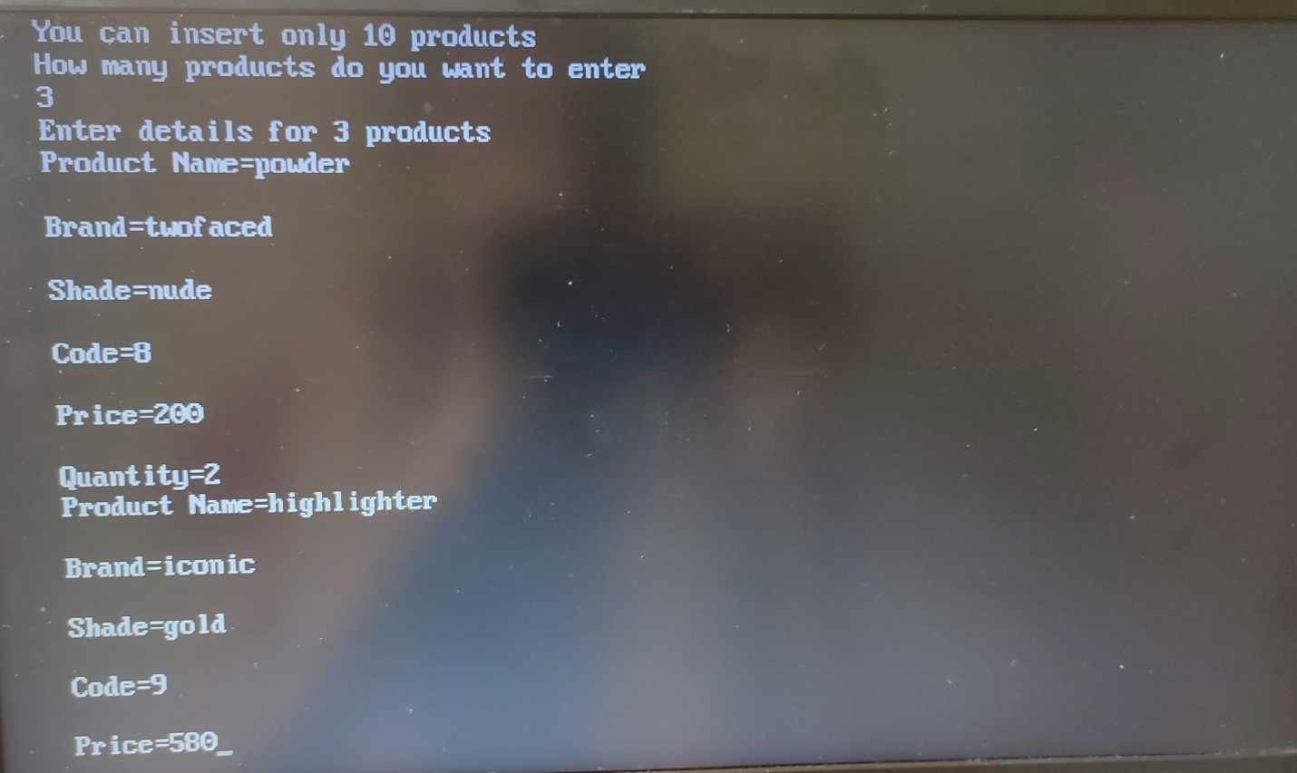

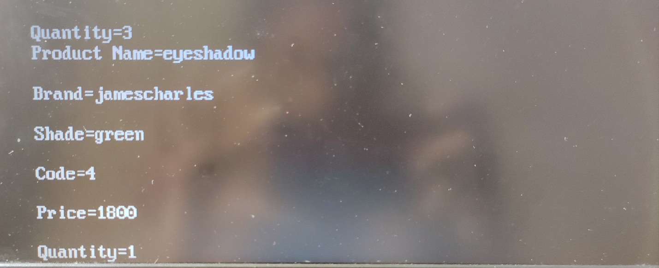

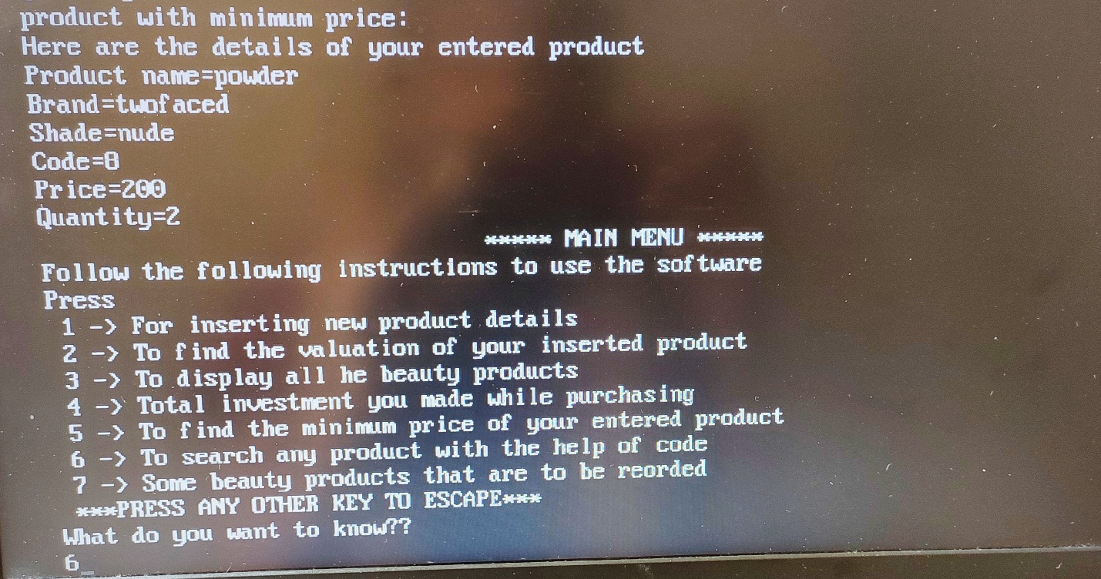

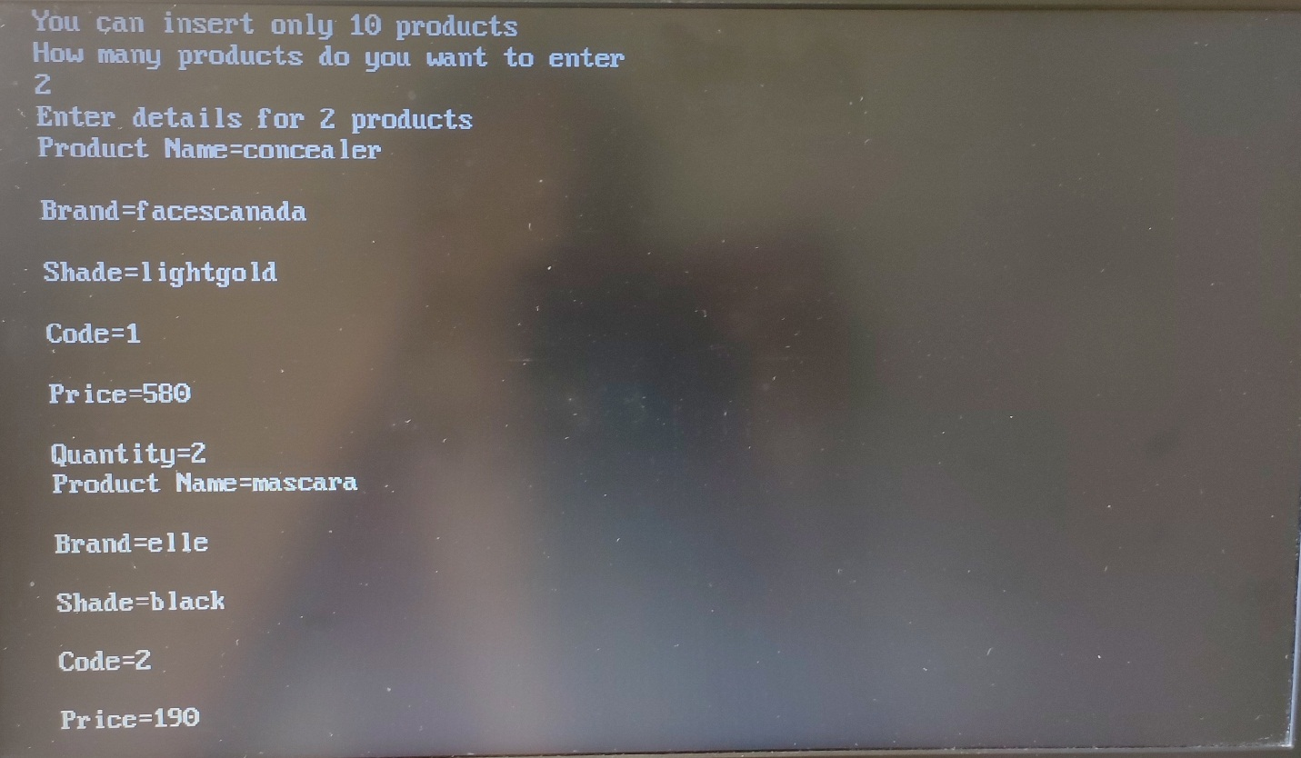

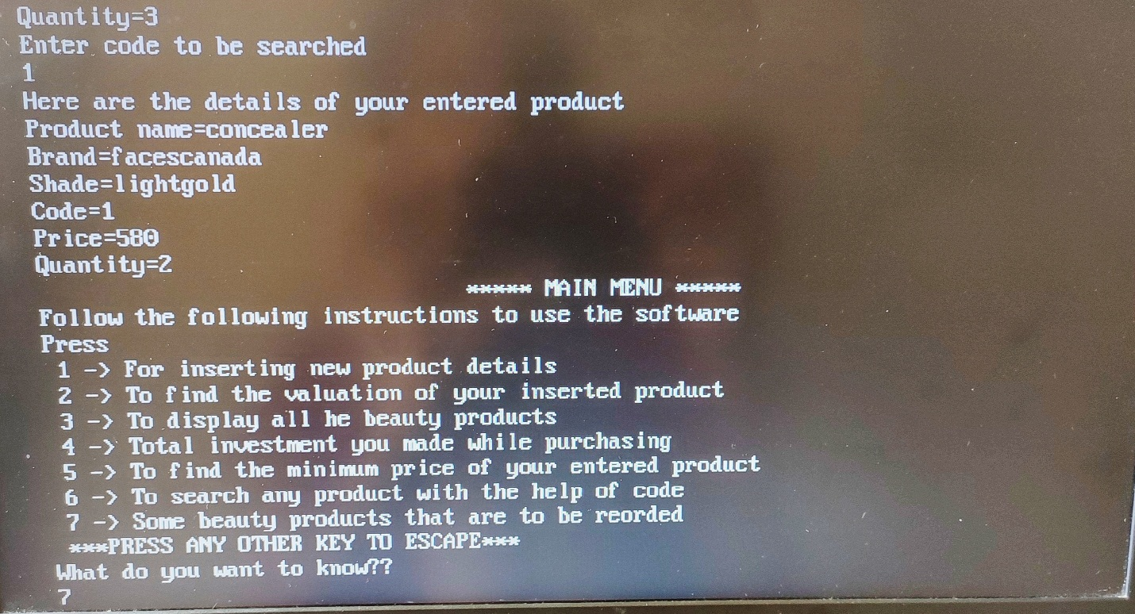

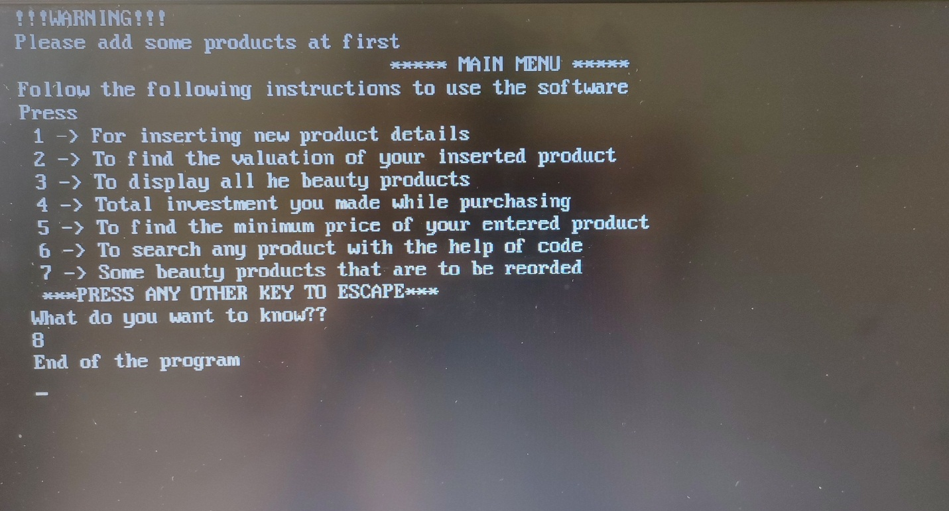

**Conclusion**

**In this miniproject, I have tried to use some concepts which were taught to us. Here, there is only one class used because I have not used inheritance and the class name is product(). Under that I have performed various activities using the data members which are nothing but variables and functions. Functions is given more importance in this miniproject. This miniproject of beauty products/cosmetics is easy to use and hence one can use it very easily.**